TERMWORK 4
NAME: name_here
USN: 2GI20CSXXX

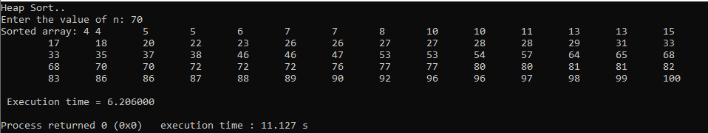

n | t
100 | 0.472
200 | 1.237
300 | 2.128
400 | 3.057
500 | 4.069
600 | 5.126

